Introducing All Creation Sings
This brief introduction is provided for synods and congregations as they prepare to introduce All Creation Sings. The information provided may be adapted for use in your context, whether for online or in-person events. It may be used in conjunction with the digital preview by providing context and background for its contents as well as addressing the resource as a whole. The individual graphics included in this document are also available as separate files for use in local presentations or materials such as PowerPoint slides or newsletters. Additional information about All Creation Sings, including the digital preview, accompaniments to assembly song in the preview, a list of hymns, and topical blog posts is available at www.augsburgfortress.org/AllCreationSings. Since All Creation Sings is a supplement to Evangelical Lutheran Worship, teaching material for ELW will also be helpful for reference. These ELW formation materials can be accessed at www.elca.org/Resources/Worship#General.
If you have additional questions or desire guidance in designing introductory materials or events in your congregation or synod, please contact us at worship@elca.org.

What Is All Creation Sings? Why Now?
- All Creation Sings (ACS) is a new set of worship resources in the Evangelical Lutheran Worship (ELW) family, designed to expand upon and complement ELW by offering a fresh and diverse selection of contents to enliven worship and the people’s song in a new day.
- The family of resources for All Creation Sings includes three editions. The Pew Edition is for the assembly’s use; a table of contents is provided at the end of this section. The Leaders Edition for the presiding minister/worship leader includes additional information and content specific to those preparing for and leading worship. The Accompaniment Edition provides full music accompaniments for the liturgical settings and assembly song, as well as additional information specifically aimed at music leaders.
- ACS continues the work and trajectory of Renewing Worship and ELW, in keeping with the intent of the 2005 Churchwide Assembly’s commending resolution that ELW would be the core of an unfolding family of resources over the next generation. It draws on several supplemental resources that have been developed for the ELCA since ELW, and it collects some of the most useful new liturgy and assembly song resources from across the churches that have been created since 2006.
- Because of the increasing pace of change over the last fifty years, principal worship books developed by churches have often been accompanied by a significant supplement at the approximate midpoint of a principal book’s life, so as to respond to those changes in church and society in the intervening years. With One Voice was released to supplement Lutheran Book of Worship about sixteen years later, and All Creation Sings comes about fourteen years after Evangelical Lutheran Worship.
- In addition to the many composers and text writers of assembly song, more than fifty people from across the church contributed directly to the shaping of ACS. These included consultative groups that met beginning three years ago; two dedicated working groups for liturgy and hymnody, supported by additional experts who made recommendations and reviewed proposals; writers of new prayers and other liturgical texts; and a diverse body of reviewers who carried out the ELCA’s thorough process of liturgical, theological, and cultural sensitivity review given to the liturgies, hymns, and visual art in resources such as ACS. (see figure)
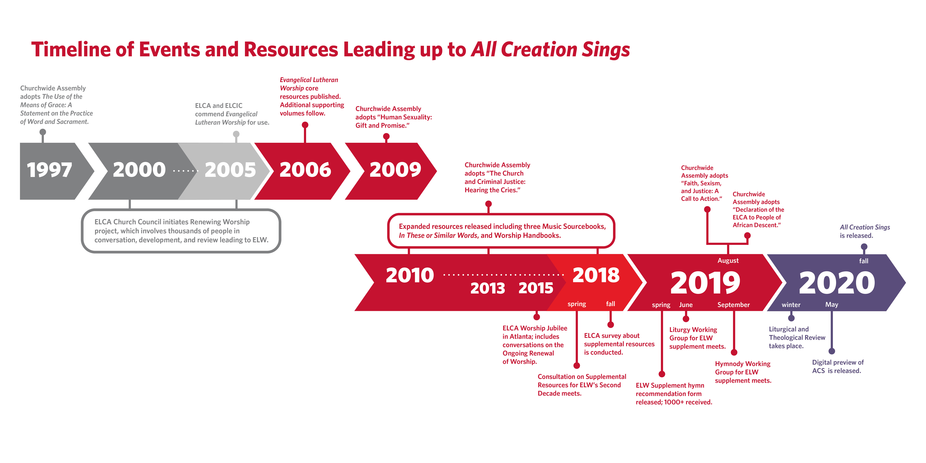
- A Liturgy Working Group and a Hymnody Working Group for ACS worked with the ELCA and Augsburg Fortress worship teams in considering thousands of content items, giving special attention to recent resources from our full communion partners and others. Among these were the Presbyterian Book of Common Worship and Glory to God hymnal; the Enriching Worship resources from The Episcopal Church; and Santo, Santo, Santo / Holy, Holy, Holy: A Bilingual Hymnal (2019), a joint project of the Calvin Institute of Worship and GIA Publications.
- ACS reflects directions and positions the ELCA has taken in the human sexuality (2009), criminal justice (2013), and faith/sexism/justice (2019) social statements adopted since the publication of ELW. Its prayers and hymn texts give attention to areas such as expansive language for God and humankind, gender identity and sexual orientation, and faithful living in a society tragically affected by systemic racism, sexism, inequities in justice and economic opportunity, and other ills.
- In addition, ACS supports other areas of contemporary concern, such as the growing crisis surrounding the environment; the fragility of human life and health among an aging population in our churches and, now, in the face of a global pandemic; and the increasing need to include in our worship cries of lament over social and personal brokenness. This attention was based on areas of concern identified in consultations and research, as well as exploration of newer prayers and hymns that attend to such issues.
- The title, All Creation Sings, evokes the scriptural themes found in the Psalms and Revelation 5. At the same time, we know that the song of creation also includes the sound of lament (Romans 8:22-23).
- Fun fact: the phrase “All creation sings” is found in hymns in both ELW and ACS.
In ELW, see stanza four of “Great God, your love has called us” (ELW 358).
Other close examples include:
ELW 560 Christ, mighty Savior
ELW 167 Now the feast and celebration
ELW 845 Voices raised to you
In ACS, “Earth is full of wit and wisdom” (ACS 1064) and “Your canopy of vigil lights” (ACS 999) both include the phrase.
Other close examples include:
ACS 946 The play of the Godhead
ACS 994 The night you gave us, God, has ended
ACS 1066 When at last the rain falls
ACS 1090 Heaven opened to Isaiah
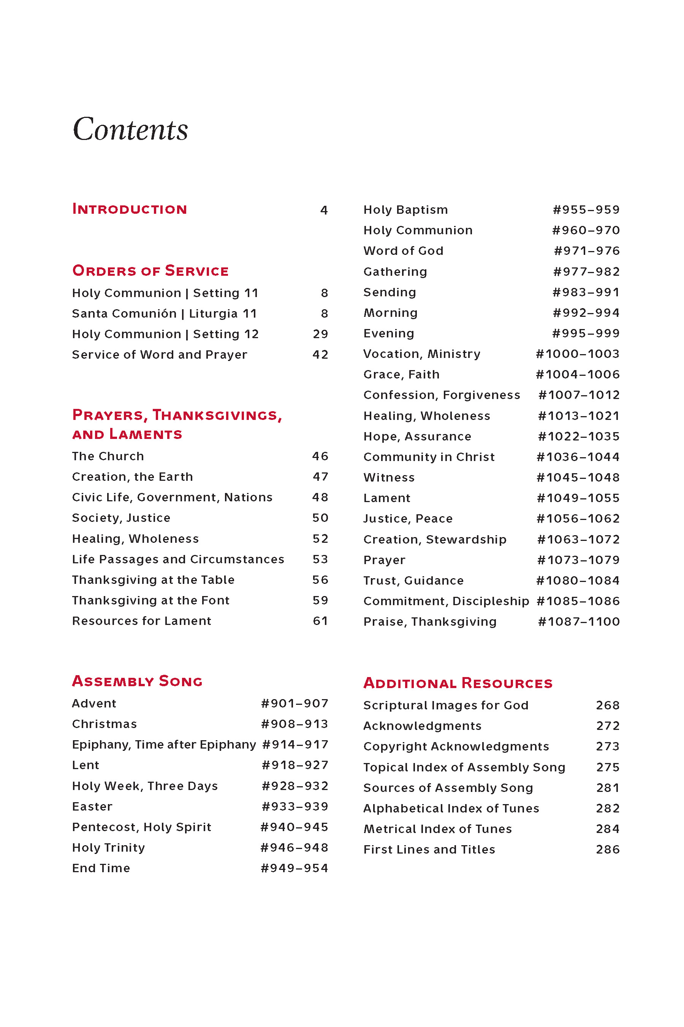
- The preview of All Creation Sings highlights portions of its contents. For a helpful overview, the full Table of Contents is provided. (see figure)

Settings of Holy Communion
- Notes in red italics are intended as helpful guides for worshipers and leaders. Some of these notes are instructions for actions or postures. Recognizing that some individuals may not participate in these actions or postures, these notes describe the action of the assembly as a whole. So, for example, “the assembly sings” or “the assembly stands” describe what the whole body is doing on behalf of all who are gathered—even though the action may not be possible for some.
- ELW provides ten diverse settings of Holy Communion that lift up the ecumenical shape: Gathering, Word, Meal, and Sending. ACS builds on this by offering two additional settings, Setting 11 and Setting 12. As with ELW, there is freedom and flexibility within the fourfold shape. Consult the pattern for worship for Holy Communion, Evangelical Lutheran Worship, pp. 91–93 (Leaders Edition, pp. 163–165) for a description of the foundational shape for the church’s principal service of word and sacrament.
- Within the two ACS Holy Communion settings, the longstanding Lutheran principles of flexibility and paraphrase may be seen in the texts of the liturgical music. Both settings employ a concise formulation of the Kyrie. The canticles of praise include an abbreviated Gloria in Setting 11, as well as a free paraphrase of the Gloria and a paraphrase of the Magnificat in Setting 12. Texts of the Sanctus and Nunc dimittis are also modified slightly in keeping with their musical settings.
- Both Settings 11 and 12 present assembly responses to the prayers of intercession beyond what is presented in ELW; for example, God of grace, hear our prayer; God of mercy, hear our prayer; Merciful God, receive our prayer.
- Both Settings 11 and 12 present new offering prayers, thanksgivings at the table, and prayers after communion.

More About Setting 11
- The spoken portions of the service are presented with English and Spanish in side-by-side columns, English on the left, Spanish on the right. In the liturgical music, this order is reversed, with Spanish presented on the top line, and English below.
- Even if you do not have Spanish speakers in your assembly, having both the Spanish and English texts in print connects us to the wider church.
- The Spanish texts in the service come from several sources. Many of the liturgical texts are from Libro de Liturgia y Cántico (1998). Additional texts are translated from ELW or are newly crafted for ACS; Sara Calderón did much of the translation work for these texts. The Spanish version seeks to capture the sense of the original texts, and at the same time it strives to recognize common usage and idioms from across the diversity of the Spanish-speaking populations.
- The words of forgiveness spoken by the presiding minister (p. 10) include the phrase, “As a called and ordained minister of word and sacrament in the church of Christ . . .” This wording reflects the change of terminology for rostered ministers in the ELCA since the publication of ELW.
- The Kyrie in Setting 11 is newly composed by Ana Hernández. The canticle of praise and post-communion canticle are from ELW but are placed here in their liturgical positions; others originate from Spanish-speaking cultures and have been given English translations. Additional musical background on the liturgical music can be found in the Accompaniment Edition.
- Several bilingual pieces from the Assembly Song section could be substituted for the liturgical music. These include “Gloria a Dios / Glory to God” (#911) as the canticle of praise, “Ayúdanos, oh Dios / Oh, help us, save us” (#1055) and “Óyenos, Señor” (#1074) as a sung response to the prayers of intercession, and the Argentine “Holy, holy, holy / Santo, santo, santo (#1089) as the Sanctus. The music which is found at ELW #473 has been expanded at ACS #1089 to include the full Sanctus text. Several other bilingual settings are included in Setting 7 of ELW and in Libro de Liturgia y Cántico.
- Two prayers of thanksgiving at the table are included in the Pew Edition. Prayer A is also Evangelical Lutheran Worship thanksgiving IX. Prayer B is adapted from “A Brief Order for Holy Communion” in Evangelical Lutheran Worship Occasional Services for the Assembly. Additional thanksgivings at the table in the Leaders Edition are forms I, III, IV, and VII from Evangelical Lutheran Worship Leaders Edition, pp. 194–202, translated for Santa Comunión Edición para Líderes. Additional forms in English and Spanish are also available in the latter two sources.

More About Setting 12
- This setting presents options for services of Holy Communion that are held in the evening. The options for evening use in this service accent the particular gifts of nighttime and darkness. See, for example, the third offering prayer (p. 35), and thanksgiving at the table, form D (p. 38).
- Anne Krentz Organ is the composer of most of the liturgical music in this setting. Much of the musical material derives from the Lenten Acclamation, “Nothing in all creation can separate us from the love of God,” which was written first (Romans 8:39). Musically this helps unify the service into one setting, and theologically it is a constant reminder that, indeed, nothing can separate us from the love of God.
- The song of praise “Glory to you, God” (p. 31) is from With One Voice. Susan Palo Cherwien wrote the text and the tune was composed by J. Bert Carlson . In addition to the embedded music provided in this setting, additional suggestions for service music are provided in the Notes on the Services in the Leaders Edition.
- Long associated with the church’s worship in the evening by its use in Evening Prayer, Mary’s song—the Magnificat—is an option suitable also for use as a canticle of praise when the service of Holy Communion is offered in the late afternoon or evening. Additional settings and paraphrases are included in this volume (#907) and in Evangelical Lutheran Worship (pp. 314–315, #234–236, 251, 573, 723, 882).
- “Behold, unveiled the vesper skies” (ACS 997) included in the Assembly Song section would be suitable as a hymn of praise, especially when communion is celebrated in the evening.
- The traditional plainsong setting of the Lord’s Prayer (ELW p. 163) is included in this setting.
- The assembly responses within the thanksgivings at the table (C and D), “The earth is full of your glory” and “Stay with us, for it is evening,” may be sung to a simple tone, introduced by the leader and repeated by the assembly. Additional options for sung responses are planned for a forthcoming ensemble setting.
- While thanksgivings at the table C and D were written before the global pandemic and the national uprisings after the death of George Floyd in 2020, their language and images seem particularly resonant with this moment in our common life together.

Service of Word and Prayer
- This service is prepared especially for contemplative settings and is suitable for midweek services, small group gatherings, or retreat settings.
- Silence and meditative song are encouraged. Many seasonal, topical, and situational suggestions for assembly song are presented in the Leaders Edition. Guidance for musicians on leading this genre of song are presented in the Accompaniment Edition.
- The physical environment could allow for freedom of movement, prayer stations, and the creative use of lighting and artwork.
- Seasonal texts for Advent and Lent are provided. Examples of contextualized services for Advent and Lent based on this Service of Word and Prayer will be available in the 2022 volume of Sundays and Seasons.
- The Word section may be structured in a variety of ways; the description of what might be included need not be strictly adhered to in its suggested elements or ordering. Suggestions for this section include the reading of scripture; non-biblical readings; brief commentary or personal testimony; a guided meditation or conversation among those present; music and other art forms. This description is similar to what is suggested in ELW Morning Prayer (p. 300).
- The Prayer section may take any number of forms. Here are some examples: a litany with spoken or sung responses, bidding prayers with ample space for the assembly to offer silent or spoken prayers, a series of collects, walking prayer, interactive prayer stations, healing prayer with laying on of hands (and anointing), prayer around the cross, prayer for the healing of the nations or for the healing of creation around a floor map of the world.

Prayers, Thanksgivings, and Laments
- ACS includes 68 topical prayers (pp. 46–55) to augment what is available in ELW. The topic headings expand significantly upon the categories in the ELW family to incorporate additional prayer concerns that have become urgently needed in our time.
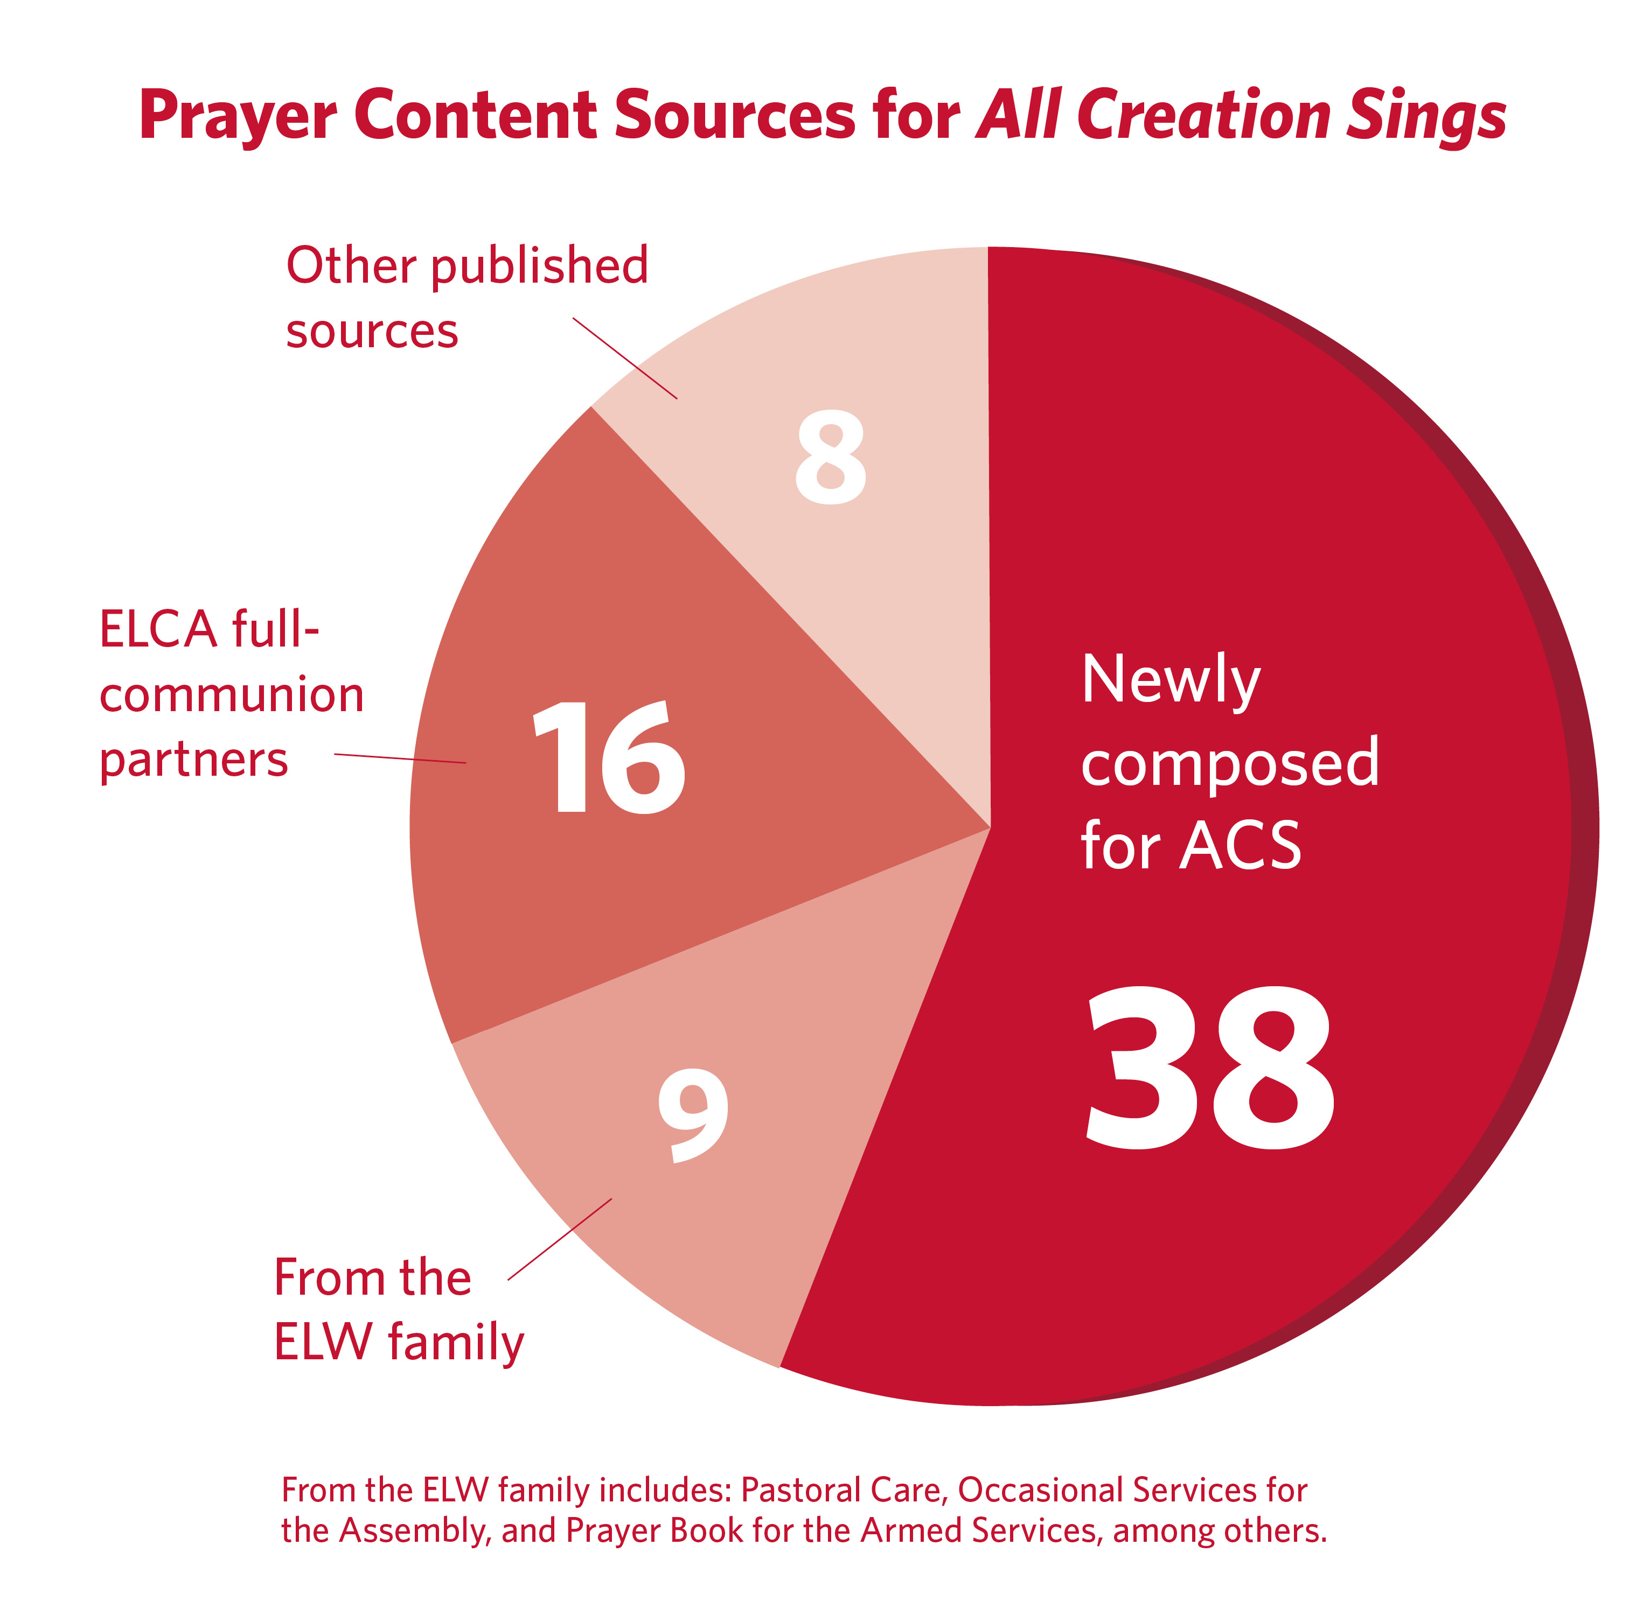
- The prayers for ACS come from many sources: 38 were newly composed; 9 came from the ELW family (such as Occasional Services for the Assembly, Prayer Book for the Armed Services, and others); 16 came from our full-communion partners; and 8 are from other published resources. (see figure)
- A diverse team of thirteen contributors from across the church suggested, reviewed, and wrote prayers for this section.
- Thanksgivings at the table E and F are from the Supplemental Resources for Use within the Evangelical Lutheran Worship Service of Marriage. The variable thanksgiving at the table G and thanksgivings at the font B, C, and D were previously published in Pray, Praise, and Give Thanks (Augsburg Fortress, 2017).
- The variable thanksgiving at the table G (pp. 57–58) is a new format. ELW uses the phrase “In these or similar words” to indicate contextual flexibility in our use of language in worship. A resource by that title published in 2015 gives background and guidance on crafting liturgical language for worship, including how to craft a thanksgiving at the table. This variable format allows for the structure of the prayer to be understood and to be contextualized as needed.
- Thanksgiving at the table H (Leaders Edition only) was commissioned by the ELCA for use in worship at its 2019 Churchwide Assembly to celebrate the fiftieth anniversary of the ordination of women.
- Two primary occasions for a prayer of thanksgiving at the font are as the assembly gathers in the service of Holy Communion and within the service of Holy Baptism just before the baptismal washing. Form A is in Setting 11 of Holy Communion, an example of the gathering use. Form B offers options for either use. Forms C, D, and (Leaders Edition) E may be used as the assembly gathers on Sunday or on other occasions when a thanksgiving for the gift of baptism is desired.
- ACS includes resources for lament. Research and conversation indicated this was an area that called for additional resources and song. A brief Prayer of Lament (p. 61) could be adapted to many situations that call forth our lament such as after a natural disaster, mass shooting or other violent event, death in a congregation or community, or others. A lament specific to gun violence is available in the Leaders Edition. Lamenting Racism (p. 108) newly composed for ACS, could be used for the work of faithful listening in discussions around racism and racial reconciliation, and at other appropriate times. A fuller Service after a Violent Event (pp. 110–11) is designed for use in a service after a violent event in the community, nation, or world.

Assembly Song
- The process to determine the assembly song included a public call for suggestions, recommendations and evaluation by a hymnody working group, staff review, and external theological/liturgical review.
- The Guiding Principles and Goals that guided the preparation of ELW also guided this process. These are listed in the Hymnal Companion to Evangelical Lutheran Worship (pp. 833–837).
- The assembly song contents continue the pattern of Evangelical Lutheran Worship, beginning with “Advent” (#901) and concluding with “Praise, Thanksgiving” (ending at #1100).
- The topic headings in All Creation Sings closely resemble ELW in order and content. Research noted several areas where additional songs were needed, especially around topics such as creation, lament, justice and society, and healing and wholeness. You will see this reflected in the contents of ACS.
- In response to research and the call of the church, especially in the Faith, Sexism, and Justice social statement (2019), the development of ACS emphasized providing texts with expansive metaphors for God and God’s people and texts without limiting language regarding gender, light/darkness, and the like. Expansive imagery in liturgical texts and assembly song includes God described as beauty, source, abba, love, word, wisdom, father, mother, strength, hope, and mercy, among others.
- Nearly two-thirds of the hymn texts in ACS are new to our resources, and half of the tunes are new. Sources for these new texts and tunes include songs newly published, hymns from other denominational resources, or hymns from published author collections.
- Familiar tunes paired with new texts include LOST IN THE NIGHT, SLANE, ROCKINGHAM OLD, ST. HELENA, THAXTED, DUNLAP’S CREEK, PICARDY, SINE NOMINE, ST. CLEMENT, RESTORATION, PROSPECT, CONSOLATION, MELITA, HYFRODOL, ST. COLUMBA, and many others.
- Familiar texts paired with new tunes include “A stable lamp is lighted,” “The Spirit sends us forth to serve,” and “When memory fades.”
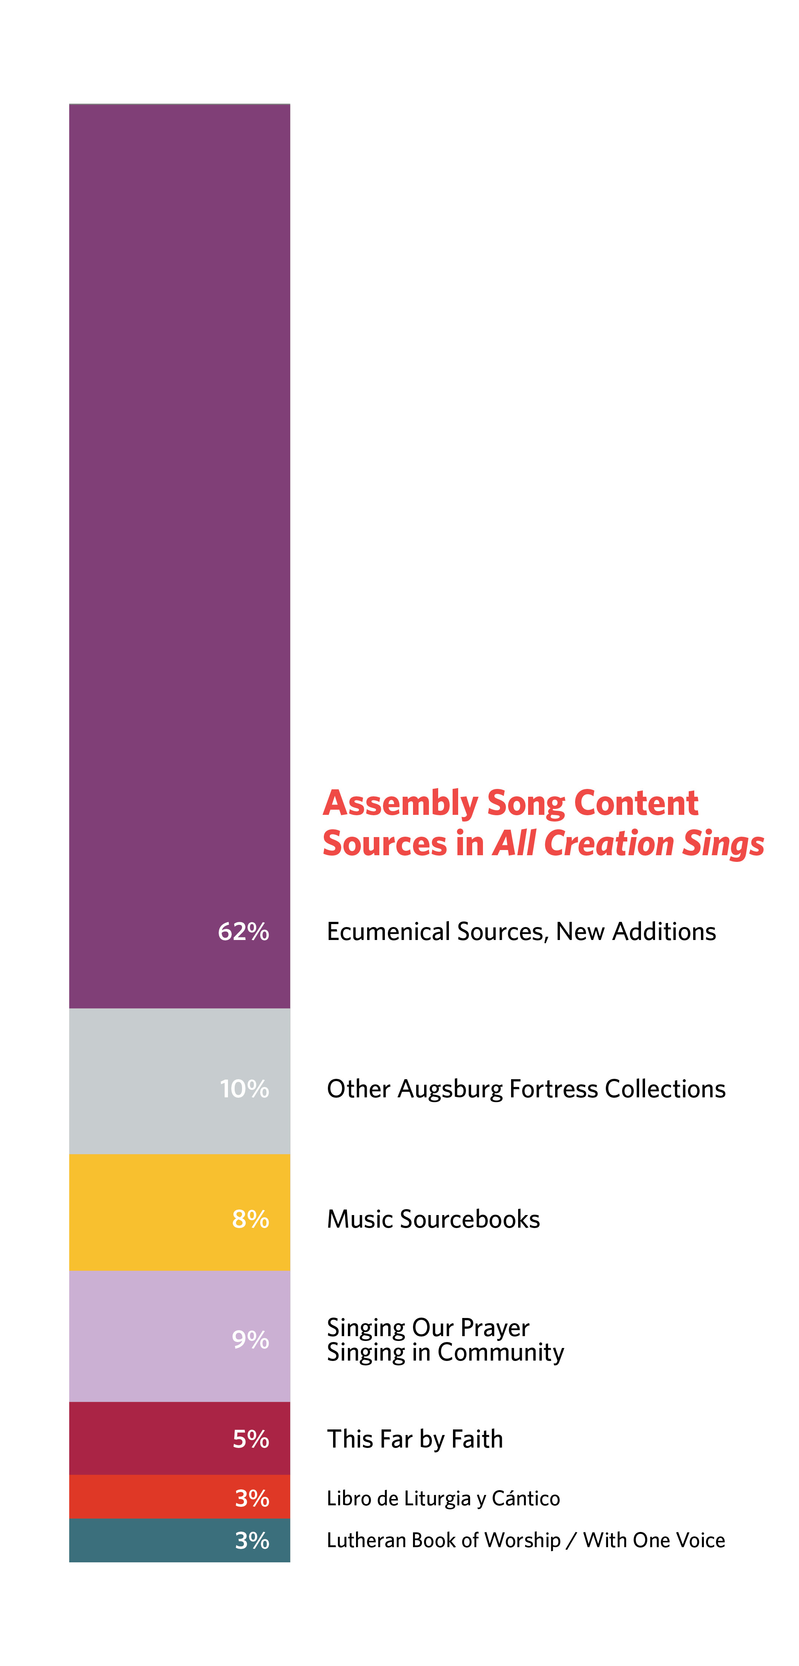
- The contents of ACS include hymns new to a Lutheran resource as well as those that were included in supplemental resources published after 2006. A small number were included in resources prior to the publication of ELW. (see figure)
- Several hymns and songs include languages other than English. ACS provides twenty-five hymns and songs with Spanish texts to accompany the bilingual liturgy that is included in this resource.
- ACS includes many shorter songs; they make up nearly one-fourth of the collection. These “short songs” are flexible, useful throughout a service, and easy for worshipers of all ages to learn and carry with them. They serve especially well around gathering and sending, baptism and communion, and in contemplative settings.
- All Creation Sings provides narrative notes at the bottom of the page for several of the hymns, a new feature not included in ELW. In the Pew Edition, these assist the assembly with pronunciation and translation for bilingual song or give other information about usage. Additional narrative notes in the Accompaniment Edition provide basic guidance for the music leader. Brief notes that are more biographical in nature and that could be used as teaching aids in printed or projected worship folders will be available on sundaysandseasons.com beginning in Spring 2021.
- ACS does not include a separate service music section. Instead, several hymns and songs that could function in this way are included in the assembly song section. A “First Lines and Titles of Liturgical Music” index is included in the Leaders and Accompaniment Editions.

Additional Resources
- While this section contains a resource explicitly named “Scriptural Images for God,” the entire contents of ACS reflects a principle of expanded imagery for God.
- The “Scriptural Images for God” appendix places a list of metaphors for God into the hands of every worshiper. They are there for everyone to hold, review, study, imagine, and pray about at any time.
- In addition to the indexes presented in the Pew Edition, the Accompaniment and Leaders Editions include a Scripture Index of Assembly Song as well as an index of First Lines and Titles of Liturgical Music.

The Art in All Creation Sings
- One challenge to artist Julie Lonneman for the interior visual images was to depict a diverse worshiping assembly without using faces or other physical characteristics, so that the art would have an open-ended, timeless quality.
- The icons for the two settings of Holy Communion use the same basic image for both, but with differences that reflect what is unique about each setting. Both icons feature a loaf of bread broken into pieces, a cup, and an open book on an altar-table. For Setting 11, the addition of the words “Glory/Gloria” signals that this is a bilingual setting. For Setting 12, the addition of a starlit nighttime background signals options for evening use, while the rising sun on the altar-table cloth signals “Sunday,” the day of resurrection.
- A singing bowl and lighted candle in the icon for the Service of Word and Prayer suggest quiet contemplation and meditation. Singing bowls and similar resonant bells are in widespread use in churches and other settings where meditative worship or other activities are practiced; the resonant tone produced by striking the bowl with the wooden striker often signals the beginning and ending of a period of silent reflection.
- The icon that introduces the Prayers, Thanksgivings, and Laments section reflects a number of themes including intercession, lament, thanksgiving, and adoration (the uplifted hands); the wideness of God’s mercy for the whole world (globe); care for the earth, home to humans and nonhuman creatures (globe); and care for one another, all of us who share life on this earth.
- The larger icon that introduces the Assembly Song section was perhaps the most fun, most delightful, and most satisfying to watch develop. People and their musical instruments are just one strand of this image. They are joined in their music-making by the swimming fish gurgling their song, the flying birds making their melodies, and the leaping deer and rabbit offering their praise. All these living creatures are surrounded by the shining sun and moon, blowing wind, flowing water, and swaying trees—a joyous chorus of all creation’s praise to the Creator!
- The sheltering mother hen which introduces the Additional Resources section is a depiction of Jesus’ description in Matthew 23:37 as he laments over Jerusalem. You can find 99 more scriptural images for God in the pages that follow, as well as a wealth of indexes that gather details about the hymns and songs in All Creation Sings into a format useful to worshipers and worship planners.

Updated October 13, 2020
Copyright © 2020 Evangelical Lutheran Church in America.
This document may be reproduced for local, non-sale use only as long as the copyright notice appears on each copy.
www.ELCA.org/Worship
www.augsburgfortress.org/AllCreationSings

